**OS Assignment 2**

**Part A**

**What will the following commands do ?**

1. echo "Hello, World!"

**Answer:- echo** command **print output** on terminal

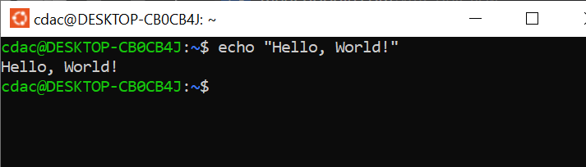

1. name="Productive"

**Answer:-**  Using **name** variable value **“Productive**” is given to that variable. Using **echo** output print on terminal as shown below:

Output:- 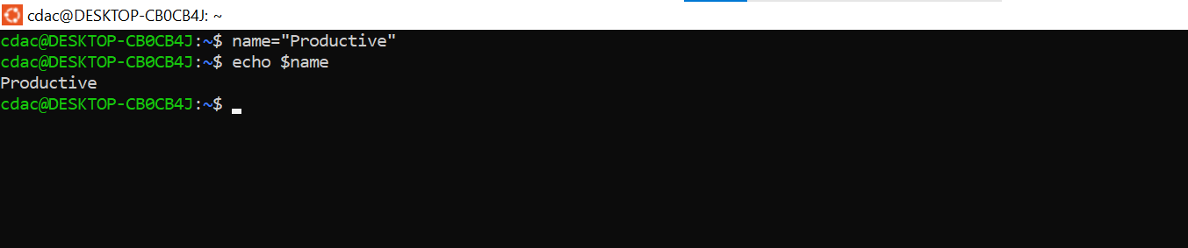

1. touch file.txt

**Answer:- touch command** is used to create file on directory with or without extension.

Example:- touch file.txt, touch file1

1. ls –a

**Answer:-** ls –a command use to print hidden files on terminal.

1. rm file.txt

**Answer:-** rm file.txt remove a file named file.txt from the current directory.

1. cp file1.txt file2.txt

**Answer:-** cp file1.txt file2.txt this command is used to copy all contents from file1.txt to file2.txt.

1. mv file.txt /path/to/directory/

**Answer:-** mv file.txt /path/to/directory/ this command is used to **moves** the file file.txt to the specified directory (/path/to/directory/).

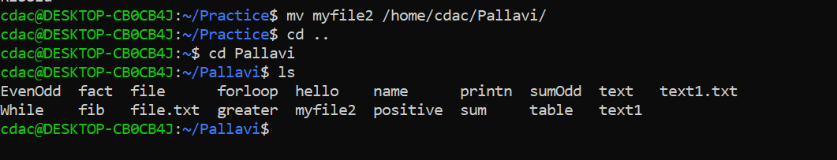

1. chmod 755 script.sh

**Answer:-** chmod 755 script.shis used to change the permissions of the file **script.sh for user/owner**, group, other.

User/owner get permission of read, write and execute.

group get permission of read and execute

other get permission of read and execute

r(read)-4

w(write)-2

e(execute)-1

1. grep "pattern" file.txt

Answer:- grep command used to search **"pattern"** inside the file the **file.txt** and prints matching lines.

1. kill PID

**Answer:-**Used to kill/terminate process ,If we know process ID we can directly use and kill process. - If we don’t know process ID we can find by command $ps aux a: Show processes for all users. u: Show the user/owner of the process. x: Show processes not attached to a terminal.

1. mkdir mydir && cd mydir && touch file.txt && echo "Hello, World!" > file.txt && cat file.txt

**Answer:-** create mydir directory after it change directory to mydir, create touch file.txt into it and redirect echo “Hello, word !” into file.txt and print this file by cat command.

1. ls -l | grep ".txt"

Answer:- ls –l command is used to lists files in the current directory in **long format**, showing details like permissions, owner, size. And grep. “.txt” command is used to print only .txt containing files.

1. cat file1.txt file2.txt | sort | uniq

Answer:- cat command is used to concatenates and displays the contents of file1.txt and file2.txt. | is used to pass the output from one command to other command. Sort is used to sort the content of file1.txt and uniq is used print uniqe contents of files.

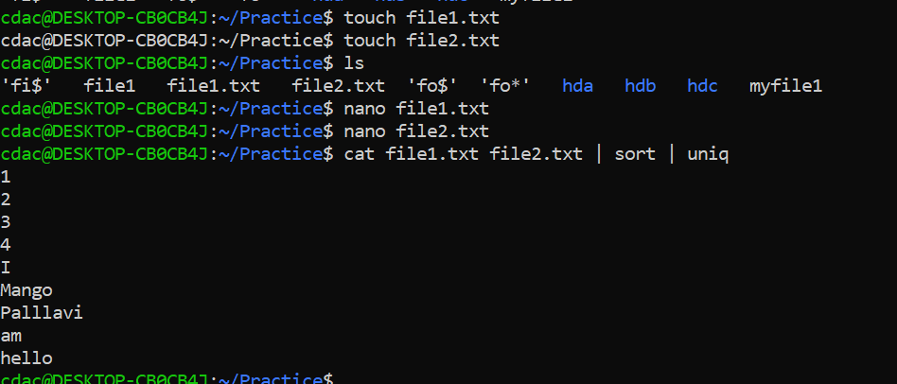

1. ls -l | grep "^d"

**Answer:- ls –l command is used to** lists files and directories in **long format**, showing permissions, owner, size, and grep “^d” is used to filters and **displays only directories**

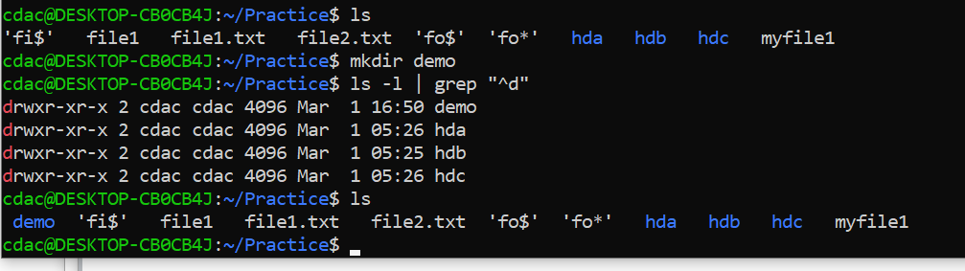

1. grep -r "pattern" /path/to/directory/

**Answer:-**  grep –r "pattern" /path/to/directory/ used to search for pattern ,strings inside all files within the specified directory and its subdirectories, and then display the output if that pattern found .

1. cat file1.txt file2.txt | sort | uniq –d

**Answer:-**  uniq –d is used to displays only the **duplicate** lines that present in both files

Sort is used to sort the content of file and cat is used to concatenate contents of files.

1. chmod 644 file.txt

**Answer:- chmod** command is used to change the permission of files. 6 for read and write for owner , 4 is for read for group and 4 is for read for other.

1. cp -r source_directory destination_directory

**Answer:- cp** is used to copy files and directories. –r is used to copy file from source to destination files and contents of that directory like file ,directory.

1. find /path/to/search -name "*.txt"

Answer:- This command is used to search for files with a specific specific pattern within a given directory and its subdirectories

1. chmod u+x file.txt –

Answer:-This command is used to give execute permission to user of file file.txt

1. echo $PATH

Answer:- - This command is used to show environment variable path

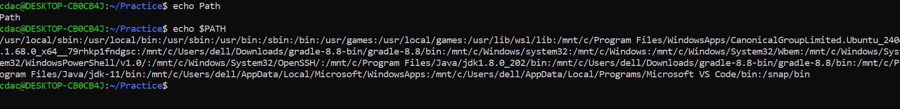

**Part B**

Identify True or False:

1. ls is used to list files and directories in a directory.

True

1. mv is used to move files and directories.

True

1. cd is used to copy files and directories.

False

1. pwd stands for "print working directory" and displays the current directory.

False

1. grep is used to search for patterns in files

True

1. chmod 755 file.txt gives read, write, and execute permissions to the owner, and read and execute permissions to group and others.

True

1. mkdir -p directory1/directory2 creates nested directories, creating directory2 inside directory1 if directory1 does not exist.

True

1. rm -rf file.txt deletes a file forcefully without confirmation.

True

**Identify the Incorrect Commands:**

1. chmodx is used to change file permissions.

chmod is used to change file permissions

1. cpy is used to copy files and directories.

cp is used to copy files and directions.

1. mkfile is used to create a new file.

nano, touch ,is used to create new files.

1. catx is used to concatenate files.

cat is used to concatenate files.

1. rn is used to rename files.

mv is command is used to rename files.

**Part C**

Question 1: Write a shell script that prints "Hello, World!" to the terminal.

Shell script: echo "Hello , World"

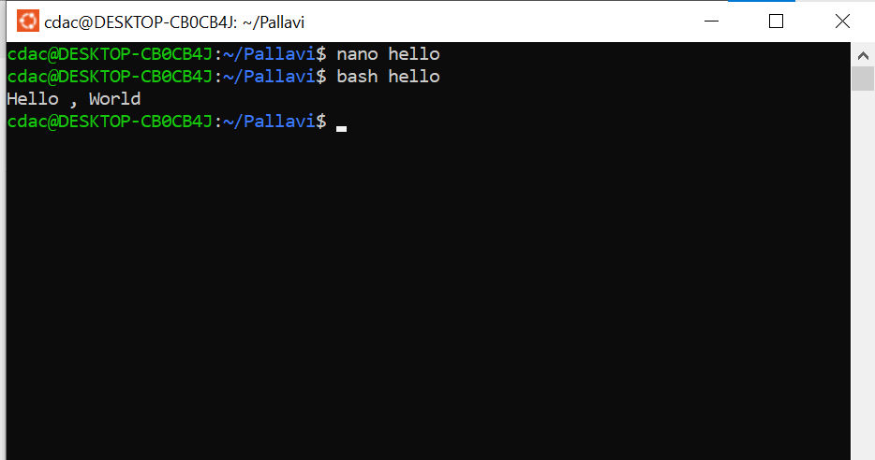

Question 2: Declare a variable named "name" and assign the value "CDAC Mumbai" to it. Print the value of the variable.

**Shell Script**

a="CDAC Mumbai"

echo $a

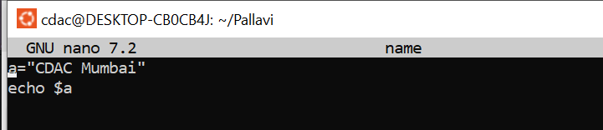



Question 3: Write a shell script that takes a number as input from the user and prints it.

**Shell Script:-**

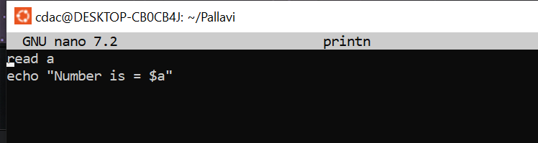

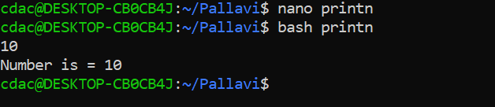

Question 4: Write a shell script that performs addition of two numbers (e.g., 5 and 3) and prints the result.

**Shell Script:**

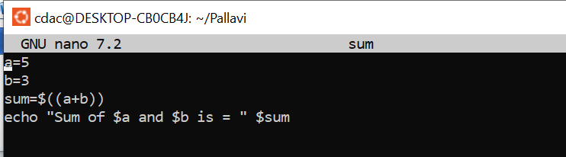

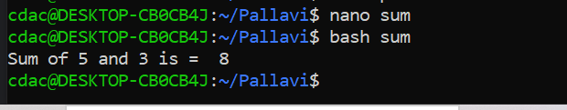

Question 5: Write a shell script that takes a number as input and prints "Even" if it is even, otherwise prints "Odd".

**Shell Script:-**

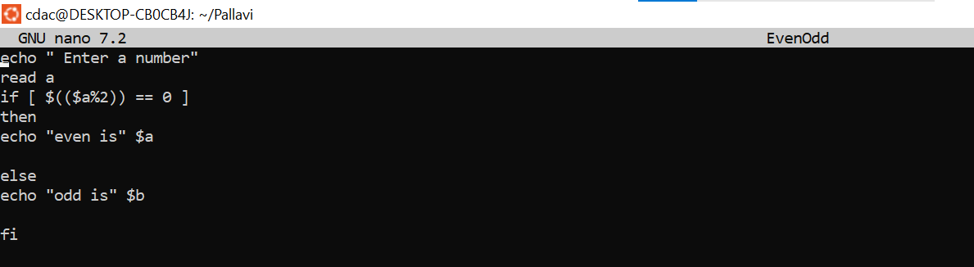

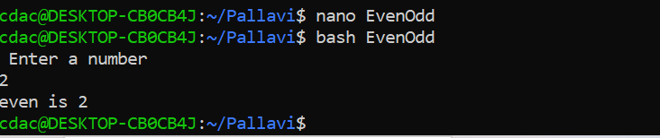

Question 6: Write a shell script that uses a for loop to print numbers from 1 to 5.

**Shell Script:-**

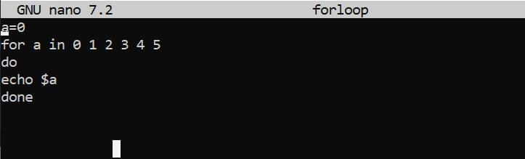

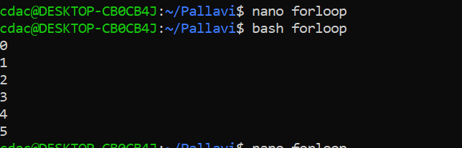

Question 7: Write a shell script that uses a while loop to print numbers from 1 to 5.

**Shell Script:-**

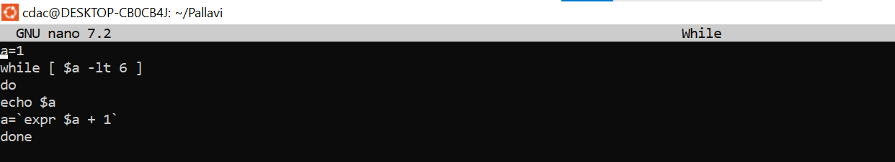

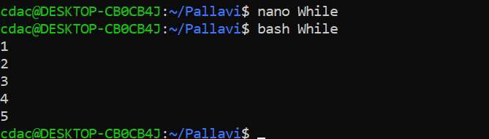

Question 8: Write a shell script that checks if a file named "file.txt" exists in the current directory. If it does, print "File exists", otherwise, print "File does not exist".

**Shell Script:-**

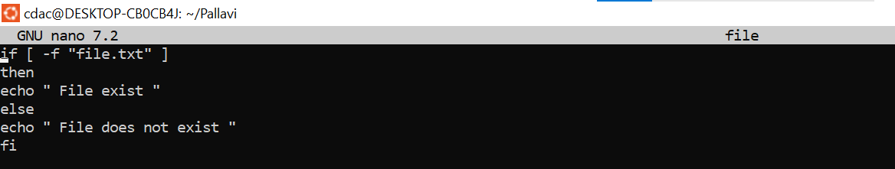

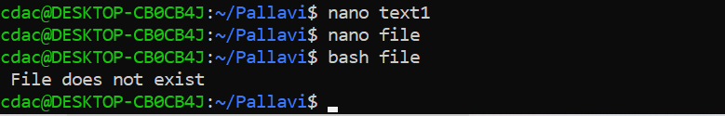

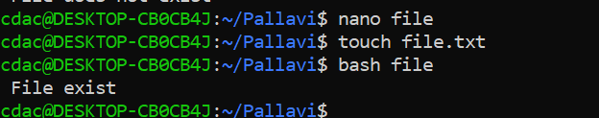

Question 9: Write a shell script that uses the if statement to check if a number is greater than 10 and prints a message accordingly.

**Shell Script:-**

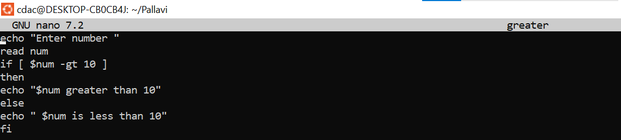

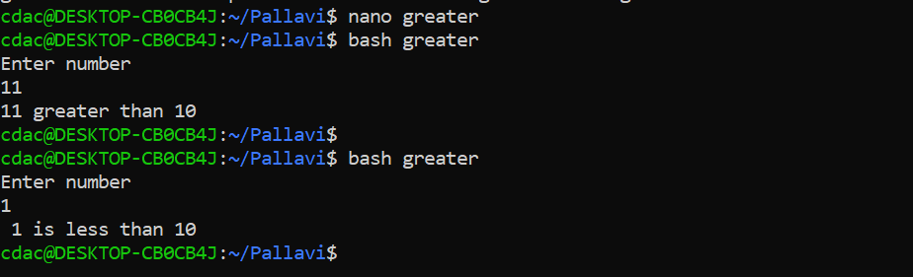

Question 10: Write a shell script that uses nested for loops to print a multiplication table for numbers from 1 to 5. The output should be formatted nicely, with each row representing a number and each column representing the multiplication result for that number.

**Shell Script**

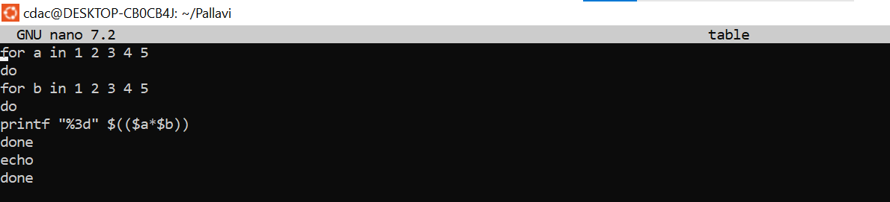

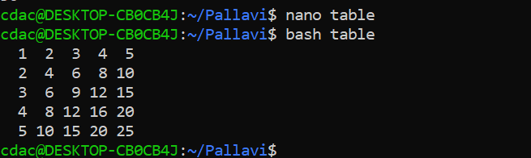

Question 11: Write a shell script that uses a while loop to read numbers from the user until the user enters a negative number. For each positive number entered, print its square. Use the break statement to exit the loop when a negative number is entered.

**Shell Script:**

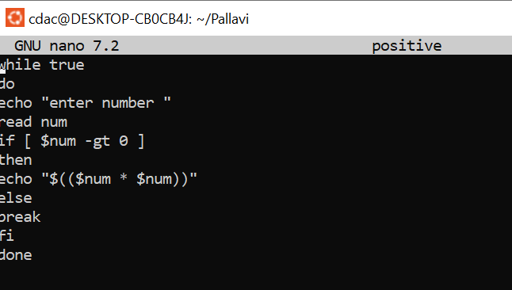

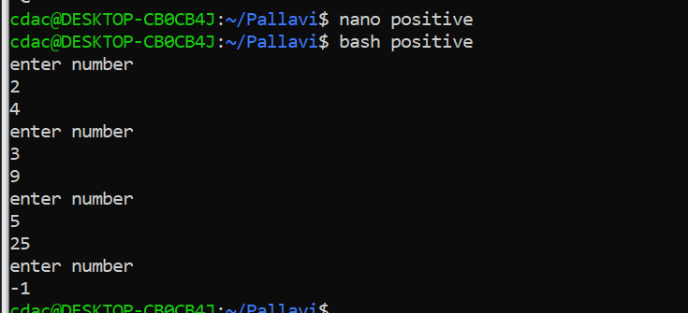

**Part E**

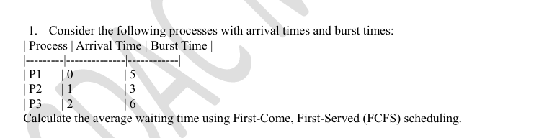

**ANSWER:-**

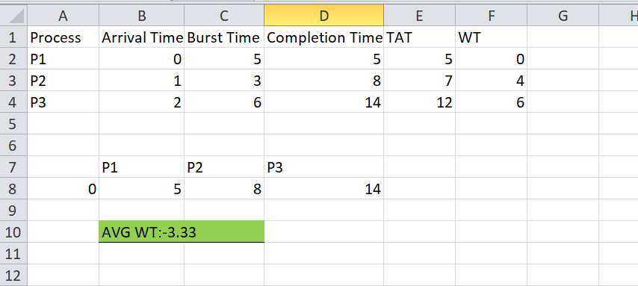

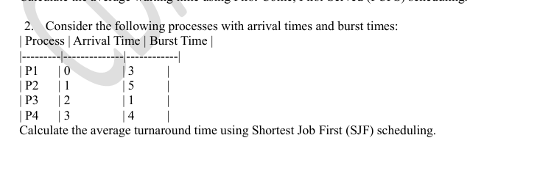

**ANSWER:-**

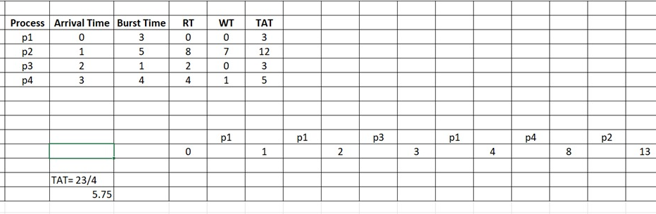

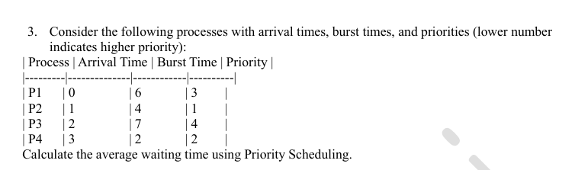

**Answer:-**

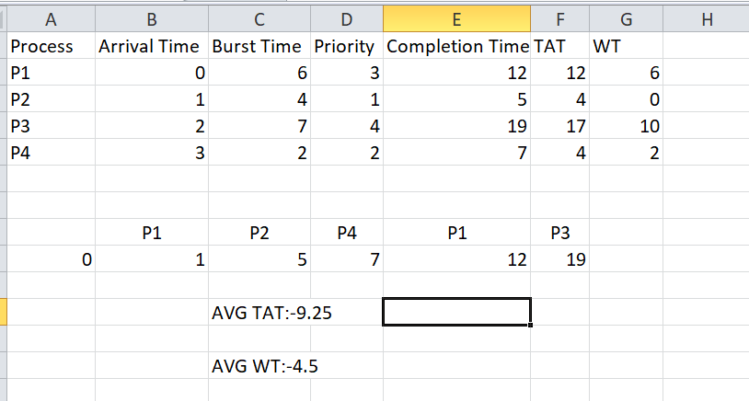

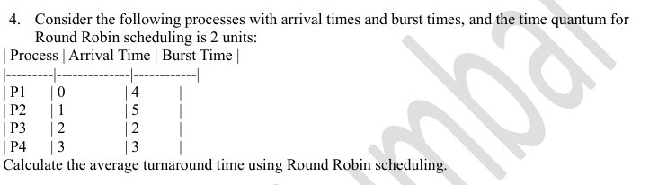

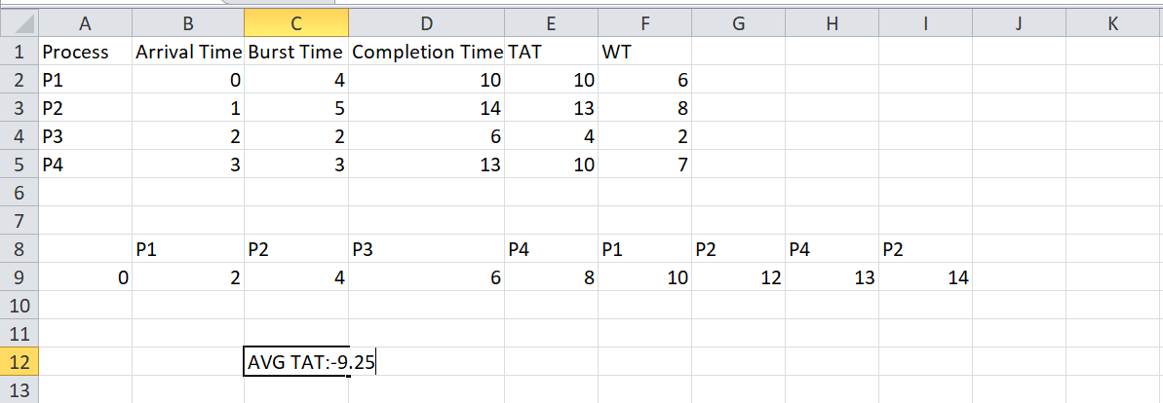

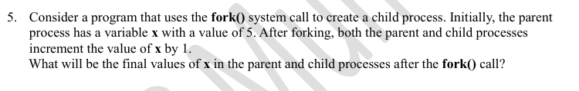

**ANSWER:**

**After execution of following code fork will create exact replica of the program.But here first main program is getting executed and then child process/program/replica is getting executed.**

**Program**

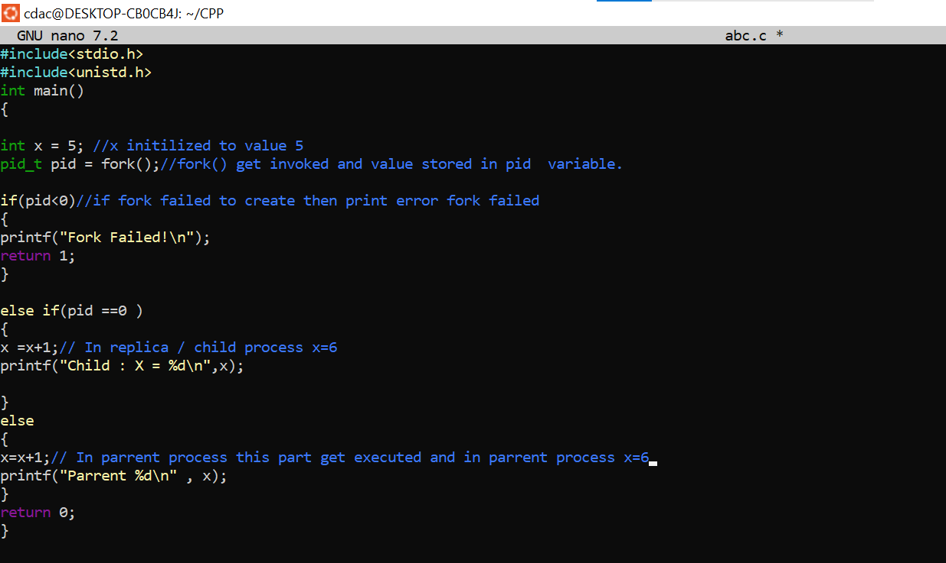

**OUTPUT:-**

